LPG DISTRIBUTION  
SYSTEM

State Diagram

Devendrakumar Raiyani (17CEUOG022 – CE107)  
Smit Patel (17CEUOS110 – CE095)

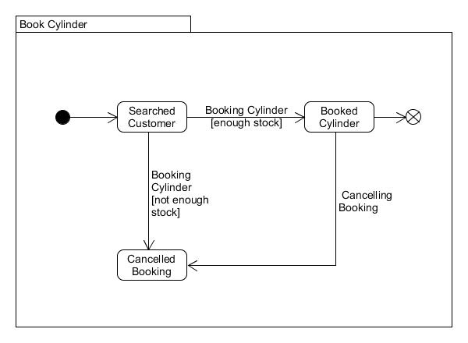**State Diagram**